Date: 26:03:2024

Day:38

1.Write a Query to create a new user in the MySQL server.



2.Write a Query to display grants for the user you created.

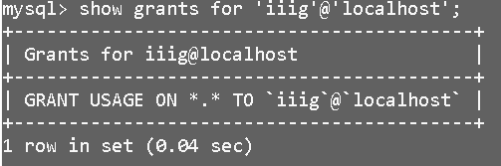

3. Write a Query to grant permissions on the database.



4. Write a Query to display grants for the user you granted permissions.

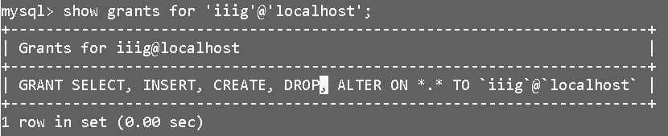

5. Write a Query to revoke any permission for the user.

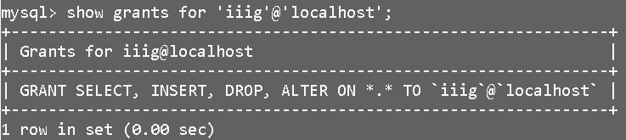

6. Write a Query to revoke multiple permissions for the user.

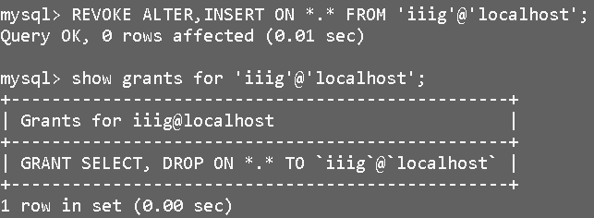

7. Write a Query to drop the user from the MySQL server.

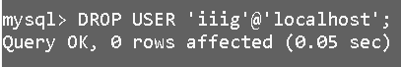

8. Write a Query to create a table student with UNIQUE, NOT NULL, DEFAULT constraints.

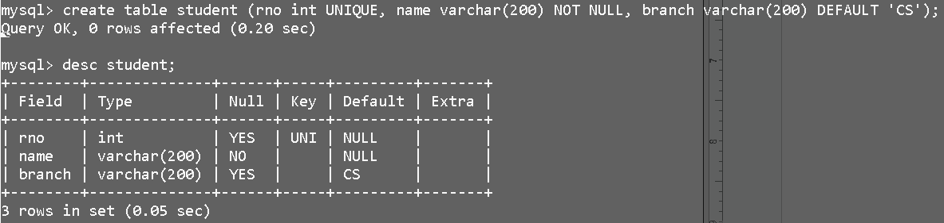

9. Write a Query to add a new column with a check constraint to the student table.

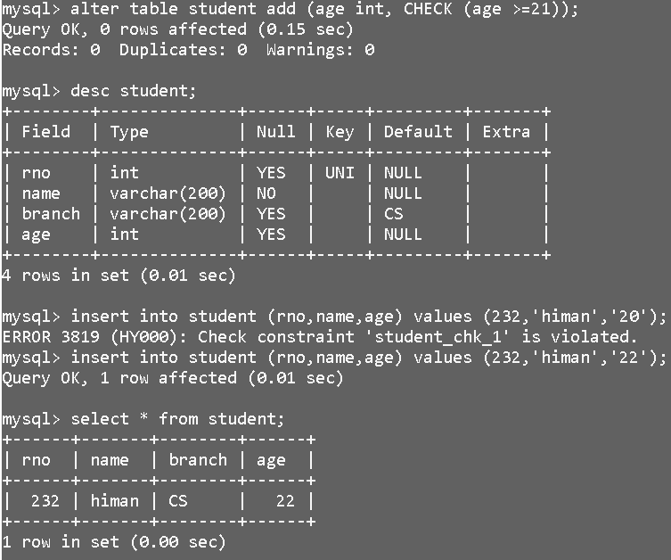

10. Write a Query to alter the table to make “rno“ column as a primary key.

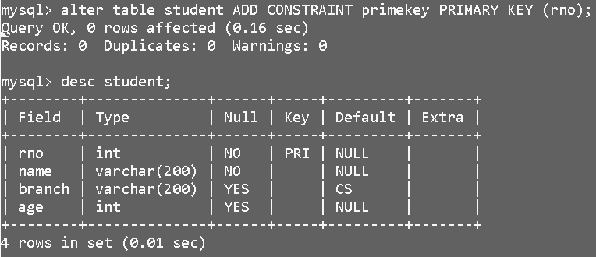

11. Write a Query to create a new table exam and make rno as the foreign key.

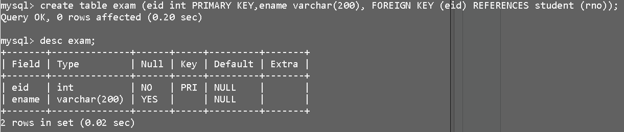

12. Write a Query to insert a minimum of 5 data records into each table and violate

constraints then insert appropriate data into the table.

